**How to Add Money Management to Your Practice**

**Guy E. Baker, MSFS, Ph.D.**

## Know YourClient

As insurance agents, we profile cases based on needs, whether they own a business, have an estate, need a pension plan or long-term care, or have a disability. Our antennae go up when we meet people who have the ability to pay and the need and are willing to talk to us. Finding assets requires similar skills. But there is a big difference.

The key to a sale is always the same, no matter the product. *Find the need*. When we prospect for life insurance sales, we are looking for liability needs: payment of debts, replacement of income, funding education needs. In the business market, the needs are varied: buy-sell agreements, key man, cost recovery. We use life insurance to transfer wealth and pay debts and fund estate taxes. All of these needs emanate from a fear of loss. Many of us use the concept identified by Solomon Huebner, the “human life value,” to demonstrate the present value of a future income stream.

When we prospect for assets under management (AUM), the focus changes. It is now on wealth building, not wealth replacement. Prospects like to talk about building up their wealth. It is a present need, and they are willing to focus on better ways to build and protect wealth. When we talk about life insurance, we are talking about a sobering event, one that removes them from the picture and does not include them in a future. With wealth management, we are talking about their future and their income. It is a different focus.

Prospecting for AUM means that we are searching for potential clients who have money to invest, a desire to change, and a willingness to explore an alternative method for investing. A transitioning executive with a 401(k), someone selling their business, and a person who is about to retire or maybe inherit money are all probable prospects. These are all life events that bring into focus a need. They make good prospects for wealth management clients. You never really know about someone’s wealth until you start talking to them. Does that sound like a fact finder?

We use a fact finder to establish a need for insurance. What is the problem? Who stands to lose the most if our prospect dies? The wife, the children, the partner, the employees? Answer those questions, and you can make a life insurance sale.

When we focus on money management, we have to discover their need as well. We have to take their temperature for investing. Do they have a broker? Are they satisfied with the service they are receiving? Are they interested in finding a new way to think about investing? What do they like about their current investment strategy, and what do they want to change? These are entirely different questions. We are looking for dissatisfaction when we prospect for money management.

Surveys have determined that more than 80 percent of all investors are dissatisfied with their current investment advisor and investment strategy. Why is it then, when you ask people if they will talk to you about investing, they say, “I have a broker I really like. I don’t want to change”? How do we tap into their concern and create an opportunity for us to become their investment advisor?

I was sitting with Bobby, an attorney I have known for many years. He had been to a dinner briefing and heard our investment story. However, he never made the decision to invest. When I visited with him recently, I just asked him when he was going to move his money over to us. He said that he was not happy with his broker and was ready to move his money now. But it took over a year from the time he first came to our dinner before he was willing to move his money over to us. Timing is everything. But let’s look at his action profile.

There are two basic action profiles: speculators and long-term investors. Everyone has to have a philosophy. The world is run on philosophy. How do you make decisions? How do you deal with risk? Ask yourself this question: *Am I a speculator or an investor*? Speculators try to time the market, find the hottest stock, and look for trends in legislation or economic cycles. They are always trying to assess the market’s temperature. Investors do not do any of these things. Investors select a portfolio based on proven metrics and their risk tolerance, and then they wait for the market to come to them.

Let’s look at the common characteristics of people you know or will meet.

|  |  |  |  |  |
| --- | --- | --- | --- | --- |
| Characteristics of a Prospect’s Action Profile | | | | |
| Attitude toward investing | Investor | Speculator |  |  |
| Propensity for Action | Early adopter | Late adopter | Never adopter |  |
| Type of decision-maker | Logical and rational | Emotional and relational | Hybrid |  |

First, based on Bobby’s comments, I could tell that he was a long-term investor, not a speculator. But he exhibited speculator behaviors. This is an important point to note, because it often means that the clients will complain about their returns and want to know how you will handle volatility and whether you like bitcoins. This is a *trap*. If you don’t set the expectations properly in the beginning, you will have to deal with these issues continually until they move to another advisor. You have to educate around these issues. He obviously was a late adopter. This is why I kept him in my inventory and did not just take him off my cultivation list.

The last attribute was a bit harder to discern. I determined that he was a logical, rational thinker rather than an emotional thinker or a hybrid. But this type of thinking is not always apparent. Why is this important? We need to know which side of the brain we are speaking to when we talk to clients. I have found that left-brain people resonate more with our methodology than the right-brain ones. They want to make sense out of the unpredictable and keep track of everything, every detail. I tell our clients that they all have one thing in common—they are really smart. They are smart because they understand how we invest money. But they are also smart because they chose to invest with us.

If you are going to successfully build an asset management practice, I think it is imperative that you know the emotional makeup of your clients. With life insurance, we appeal to emotions. People buy life insurance because they love someone or something. The purchase of life insurance is a character purchase in the final analysis. They are really doing something for someone else. With asset management, they are doing something for themselves. It is a different mind-set and requires a different way of thinking about the client relationship.

Remember, you are looking for clients who are emotionally connected to your style of management. You don’t want to build a client base you cannot manage. It is important to know your management style and philosophy. Life insurance clients are very passive. They are not demanding information on a regular basis. They don’t need hand-holding. Asset management clients are an ongoing relationship. They want tender loving care, so you have to build an organization that can provide this service.

Dimensional Fund Advisors recently did a study of almost 20,000 investment clients. The No. 1 reason clients stayed with their advisor was peace of mind. They wanted to know that their advisor knew their situation and had experience with clients like them. These issues were more important than returns. Although returns were a key factor to their satisfaction, it was not the only thing, or the main thing, that kept them loyal to their advisor.

We work hard to find prospective clients. It hurts when we don’t make a sale or we lose a client relationship. With life insurance, repeat sales come from repeat contact, but sometimes there are years between sales. In money management, you retain and grow assets by continually nurturing your clients. Frequent contact builds relationships and brings referrals.

The price tag of picking the wrong prospect is that you waste your time. This is true in both the insurance and the money management world. You need to be able to determine whether you have a prospect quickly. So ask a lot of questions. A bad money management client can cause you a lot of problems. It is important to select your clients with care.

The ideal insurance sales process has several steps; the same is true with gathering assets. You have to establish the need, do a fact finder, provide an analysis of your findings, make a recommendation, and get a decision. Like the insurance sales process. Gathering AUM starts with a critical angle. You have to get their attention. What is your critical angle?

When talking about gathering assets, there are two critical angles I have found to be intriguing to prospective clients. The first is to ask them if they know how much risk they are buying. Most people have no idea what this means, yet it is probably the most important differentiator between us and our competition. Here is an example of why this question can help you gather assets.

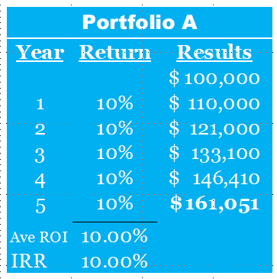

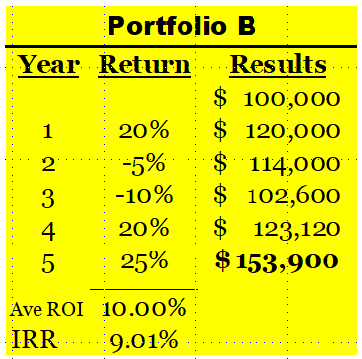

Suppose you have two portfolios. One earns 10 percent every year for five years. The average is 10 percent, but, more importantly, the internal rate of return is 10 percent. The second portfolio bounces around, up 5 percent, down 15 percent. But the average is still 10 percent. No difference, right? Wrong. Invest $100,000 into both. With the 10 percent IRR, the value of $100,000 is $161,051. Look at the value of Portfolio B, which still averaged 10 percent but jumped around. It is only $153,900. Why? The IRR is 9.02 percent, nearly 1 percent less. Most investors do not appreciate how important managing risk is to their overall results. You can add value by managing the amount of risk a client buys.

The second critical angle relates to a study published by the Transamerica Retirement Institute. It reported that 85 percent of Americans do not know how much capital they need at retirement to fund their lifetime income needs. I ask this question, “Do you know your number?” You may remember the TV ads. This comes from Lee Eisenberg’s book *The Number*.

When I am asked what I do, I say, “I help people answer the three most important questions about their personal finances, questions almost no one can answer.” Then I wait. Usually, they will ask me what the three questions are. Then I say, “Do you know your retirement number? Do you know how much you need to save every month to reach your number? And, third, do you have an investment strategy that has the highest probability of achieving the optimum return for the lowest risk so that you can reach your number?” Then I just wait until they respond. This usually starts a conversation, and I invite them to my office to discuss their situation further.

I always ask for a copy of their most recent portfolio statement. Once I get their portfolio statement, I can try to win their confidence in one of two ways. First, I can show them a sample of our work and what we have concluded about their portfolio. This means that I will compare their risk tolerance to their actual portfolio allocation. I also will do an expected returns analysis comparing the returns on their portfolio over 40 to 50 years to portfolio allocations we use. A second approach is to teach them our methodology and show them the problems most investors face. I show them how our approach will provide them with a better investment experience over the long run.

One method is process; the other is solutions. I have found that people don’t care about the solutions until they *know* they have a problem. If you sell the solutions too soon, you are most likely going to lose the prospect. But if you sell the problem, then they will want your solutions. Educating them before you show solutions is a proven process, and it has the highest probability of success.

Once they are educated, then I can show them how our analysis has deconstructed their portfolio to see how it is built and how we determined the amount of risk they are buying. And then we show them how to match their risk tolerance with their portfolio risk.

We ask, “What is your allocation and how much risk are you buying?” After we educate them on our investment process and how we help our clients meet their retirement objectives, they have a choice to make. We show them how to reposition their assets to optimize their return and either reduce their risk or keep the risk the same. When they understand risk, they understand the benefits of our investment strategy.

I call this the “couch meeting.” I invite them to my office, and, on a large screen monitor, I run a PowerPoint presentation to show them important elements of investing. I show them how we build a portfolio and introduce the probabilities of reaching their investment objectives.

Another tool that is quite effective is our Simple Retirement Calculator. It shows them how their current plan is going to hold up in retirement. Here are a couple of screenshots of our calculator’s output.

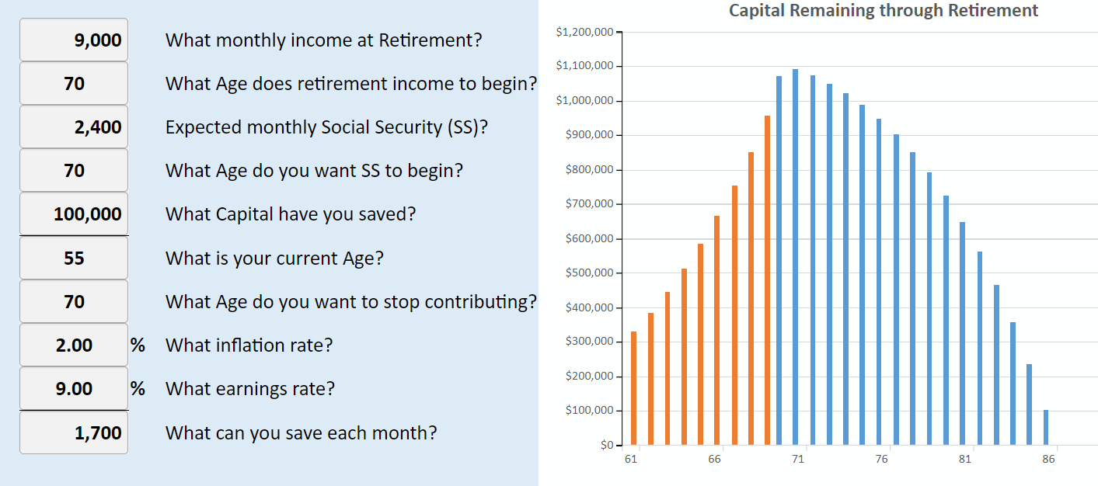

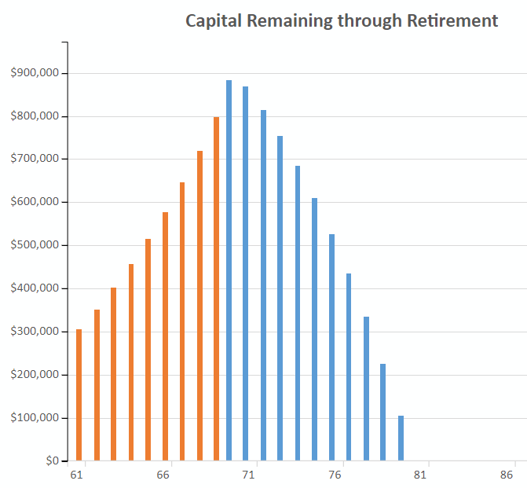

This first one shows a 55-year-old who has accumulated $100,000. He wants $9,000 a month, starting at age 70. He thinks he will earn 9 percent on his money and inflation will be 2 percent. He is able to save $1,700 a month. His expected social security benefit is $2,400 a month. So his capital will need to produce $6,600 a month. Using the 20 times rule of thumb, he will need $1.3 million at retirement to fund a lifetime income from capital. You can see from the graphs that, at $1,700 a month, earning 9 percent, he will run out of money at age 86. If he can only earn 7 percent, he will run out of money at 79.

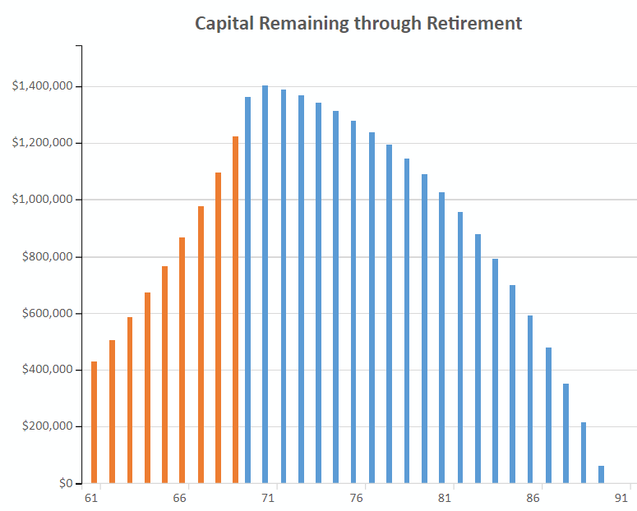

Using the calculator, to reach his goal of $6,600, inflation adjusted, he will need to save $3,000 a month to push his income out to age 90.

Like selling life insurance, you have to demonstrate that they have a problem and help them understand the magnitude of the problem if they don’t do something about it. The same is true of asset gathering. You have to convince them of two things to win their business.

First, you need to show them that their current plan is *not* going to get them to their end game. If you can show them the size of their shortfall, and then show them how your allocation and investment methodology will solve their problem, you have taken a significant step toward winning their business. The second thing I do is to show the differential in cost between our solution and what they are doing. I show how this cost savings can provide them with a high probability of reaching their goal by saying:

Look at this simple chart. If you invest $1 million today at 10 percent hypothetical return for 25 years, and if the total fees are 1 percent, the value of the account will be $8.6 million. But if the fee is 2 percent, only a 1 percent increase, the value reduces by 21 percent to $6.8 million. But if the fee is 3 percent, there is a 37 percent reduction to $5.4 million. Our fee, all in, is around 1 percent. Based on what we have learned from studying other portfolios, the fees are much higher. You might want to allow us to review your portfolio to determine what your fees are.

This may not close the sale, but it will certainly open up their thinking.

That is how I position our wealth management process—critical angle, education, and analysis.

What do clients want from their financial advisors?

## Value of Advice

Studies show that investors are focused on more than investment performance. Survey respondents place the most value on their sense of security from working with their financial advisor. They want to know that you are there to protect their best interest.

When asked how clients discern the primary value they receive from their advisor, these are their top four responses:

1. I know the advisor cares about me and I have peace of mind.
2. They know and understand my financial situation.
3. I am making progress toward my goals.
4. I am receiving a reasonable return on my investments.

How do you achieve this type of response from your clients in the investment world, a world that is so random? This is done by establishing proper expectations through education. You can sell process and service, or you can focus on return. Satisfied clients know markets go up and markets go down. They want to know that your process will give them fair treatment and that they are not exposed to undisclosed risk. To the extent that you can comfort them and show them that your investment offerings are manageable and durable, you will satisfy their concerns.

When asked what the primary or most valued attribute is that their advisor demonstrates, four characteristics were at the top of the list. At the top of the list was investment performance. They want a process that follows their benchmark at a minimum. But the next three are very interesting:

1. The client service experience—communication and information
2. Experience with clients like me
3. A range of services and expertise that will benefit me and my family

As insurance advisors, we soon learn that we have to keep prospecting to add clients to our client base. Service is important, but with life insurance, there is no expectation or requirement to contact your client several times a year. That is not true with investments. The client experience is code for *I want to hear from my advisor more than once every five years*. Surveys show that clients want to hear from their advisor three to five times a year. That is a culture shift and requires creativity to meet this need and still grow your business.

When asked what information their advisor needs to provide to help them have peace of mind:

1. If they are approaching retirement, an estimate of the income they are likely to derive from their portfolio
2. The sustainability factor—how likely am I to maintain this income?
3. Total nest egg—is it growing or reducing?

Think about yourself and money. How important is your investment portfolio to you? Do you check it frequently? Do you want to be able to talk to someone about your performance? Your attitude and needs are quite similar to your clients. So you need to set the expectations properly and then do your best to meet them.

For clients who are already in retirement:

1. The amount they can spend becomes even more important.
2. What average annual return can I expect on my portfolio?
3. What is my total retirement nest egg?

Clients want to know that you have a plan and you have the discipline to follow it for them. If you can show them a plan that makes sense and how you will deliver on the plan, they will be content, and they will refer you.

When investors are asked about their greatest fear, the four most often heard responses are these:

1. Not having enough money to sustain their lifestyle through retirement
2. Fear of experiencing a significant investment loss in a market downturn
3. Outliving their money
4. Incurring unforeseen expenses

Our job as their advisor is to show them that there is elasticity in their plan and that we are able to protect them when chaos hits. Having a logical and workable plan to protect them from another 2008 market crash is critical. How you communicate your plan and how you execute it will retain clients and attract new ones.

Knowing these important client preferences is the blueprint for building a successful practice. For who would start to build a building without first counting the cost?

Before I close, I would like to share four important keys I discovered for developing a successful business:

1. *Your mission statement*. Why are you in this business? What is your driver? It has to be more than just wanting to make an income. If you have not watched Simon Sinek’s *Start With Why* video, you should do so. He frames our mission around the *why*. His point is that people do not care about your *what* or your *how* until they resonate with your *why*.
2. *Vision*. What do you want your business to look like five or 10 years from now? This is a form of Dan Sullivan’s famous question: If you and I were to be talking five years from now, what has to have happened in your business for you to feel you have accomplished what you set out to achieve? Do you want a firm that manages $100 million AUM or $250 million? How many employees? What services do you want to offer? Your vision will dictate your path.
3. *Goals*. What is reasonable? Everyone needs goals. They are the guardrails to success. Without goals, how do you know whether you are anywhere near your objective? Good goals are daily goals. The one I used for my entire career was what I called “two-a-days.” Find two people every day who will agree to talk to you about their investment program. Ask this question, “Most people I talk to cannot answer three simple questions about their long-term financial success. I wonder if you can? Would you mind discussing these questions with me?” Find two people every day who will sit down with you to discuss their number, their savings plan, and their investment process.

Finally, why are you in this business? This is a form of the mission statement. But the core of this answer is your motivation for paying the price you will pay to go into money management. Unless you have a clear commitment to this service, you would be better off delegating it to someone and just concentrate on finding people who need someone to help them.

There are three skills you have to master to successfully add money management to your business. You have to do the following:

1. Learn how to gather assets
   1. Philosophy about markets/stocks (disappearing funds)
   2. Develop an elevator talk—“What do you do?” Financial coach/advisor/manager/facilitator/risk manager
      1. Critical angle—what distinguishes you from all the other asset gatherers? How do you explain this to your clients? COIs?
      2. Three questions—number, savings, and investment process
      3. How much risk are you buying?
      4. How to transform your database—through marketing/relationship/expertise
2. Learn how to manage assets
   1. Two options as an advisor—RIA/IAR
   2. As a product salesperson—annuities, life insurance, and mutual funds
3. Learn how to service your clients—keeping in touch through media, personal contacts, and seminars

The future, in my opinion, of successful financial advisors is a person who can master both sides of the financial statement. They need to protect clients against the liabilities of life, and they need to help them capture and grow their wealth. There is no advisor in the financial services industry more skilled, trained, or talented than an MDRT member. I hope this session will help you get on the right track and stay there.