**Prioritizing Profitable Prospecting: How to Overcome Sales Call Reluctance**

**Connie Kadansky**

If I asked if you would give me $1 for a $100 bill, would you come forward? If so, what would you have to do to capitalize on the opportunity? What was going through your head when I made that offer? Did you take a risk in coming forward? What was that risk? Opportunities are everywhere. We need to recognize them and capitalize on them. How many opportunities are you missing because you talk yourself out of them?

To prospect consistently and successfully, advisors need the foundation of a vision that magnetizes them beyond their comfort zone. Vision is the starting point of all high performance. You create things twice—first mentally, then physically. The biggest barrier to high performance is not the physical manifestation but the mental creation. You will never outpace your mental models. Vision is the first place where you engage your thinking about what is possible for you. Vision creates ownership.

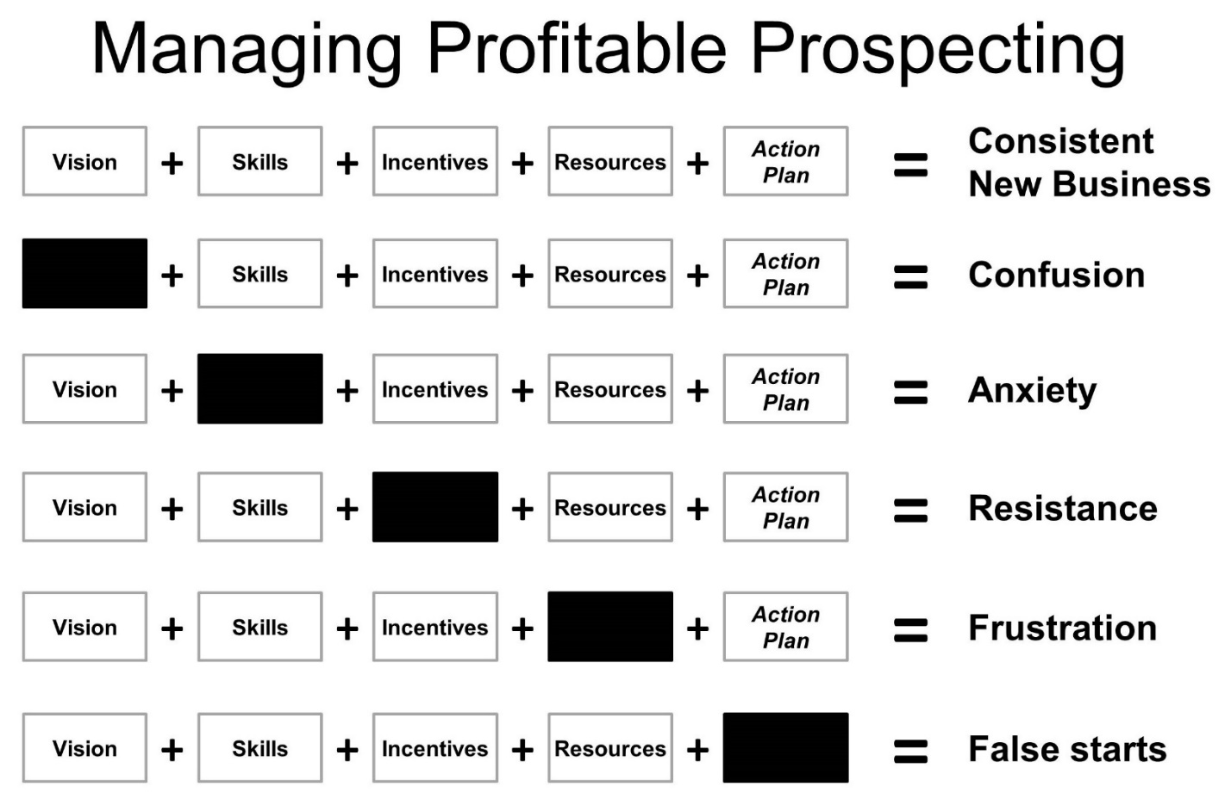

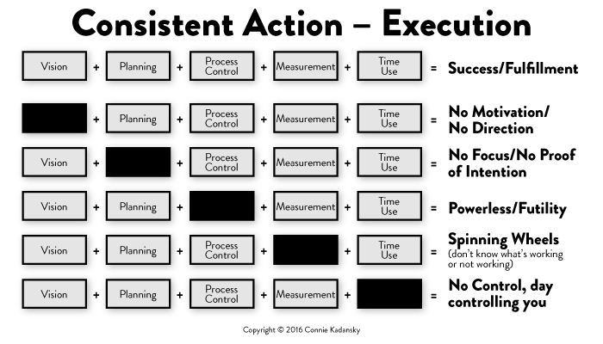

What is missing in your Profitable Prospecting Equation? What is missing in your Consistent Action Equation?

Use this mind-set: “I am a professional lead generator who happens to sell insurance.” Admitting this as a fact does not diminish your education, experience, and credentials. It is a mind-set that you are responsible for generating your leads.

Everyone needs three vibrant lead generation channels. I will talk about the high-value activities that advisors are 100 percent responsible for on a consistent basis.

Having an outward mind-set: You solve people’s problems for a profit. You are on a rescue mission to help people achieve their goals to protect their families, businesses, assets, and legacy.

When salespeople hesitate to prospect and promote, they are focused inward (self-protect mode). They see the proactivity as a “threat.” Sales call reluctance is fear. Fear is a mental response to a perceived threat.

There is uncertainty when we prospect. Uncertainty fuels anxiety. It is the not knowing that leads to distress that stimulates fear. Fear creates doubt, and doubt wastes energy. There is one beautiful aspiration/characteristic that takes away the need for certainty. Guess what that is? Curiosity!

How do you know if you are experiencing call reluctance? How much money is in your wallet? Your investment portfolio? Call reluctance shows up first in your bank account.

There are only two ways to experience prospecting: as an opportunity or as an emotional threat.

Sales call reluctance is the emotional hesitation to prospect and promote.

There are four steps to overcoming sales call reluctance:

1. Aware
2. Assess
3. Admit (not comfortable to admit)
4. Apply (proven techniques)

Confidence is the ability to transform fear into focused-related thinking, communication (internal and external), and action.

What blocks your prospecting success?

* Limited beliefs
* Assumptions (experience + emotion)
* Perspectives/interpretations
* Inner critic (usually mean and destructive)

Fear of rejection is one of the biggest reasons people hesitate to prospect. Fear of rejection is a negative interpretation, which throws you into negative emotion, negative behavior, and negative results. No one can reject you unless you are rejecting you. Fear of rejection is an inward mind-set (self-protective barrier).

I will touch on the four major types of call reluctance for advisors. Role rejection is the number one toxic type of call reluctance for selling insurance. Sales managers, trainers, and speakers are the number one carriers of this type of call reluctance. They are unknowingly contaminating the very people they intend to inspire by their own role rejection call reluctance. “I am not trying to sell you anything” is classic role rejection call reluctance speaking. It is not true. The salesperson is trying to “sell” the prospect on being open to meeting. This statement blows the credibility of the salesperson and causes distrust. The prospect knows that the salesperson is selling, and it is OK!

**Over-prepare call reluctance:** Overanalyzing the prospecting activity, scripting, etc.

**Yielder call reluctance:** More concerned about the relationship than the value he or she provides to the prospect.

**Referral aversion call reluctance:** Not comfortable leveraging the relationship for referrals. Julie Littlefield of Absolute Engagement points out that the reason clients refer may have very little to do with helping the salesperson and much more to do with helping a client, friend, family member, or colleague. “Clients are more likely to provide a referral to help a friend, rather than help their insurance salesperson.” Positioning for referrals in a way that clearly demonstrates how the salesperson can help a client’s friend is more effective. Referrals happen in the moment and are motivated by the needs of others.

**Social self-consciousness call reluctance:** Intimidated by an up-scale prospect—wealth, education, prestige, status.

## The Neurochemistry of Prospecting

Amygdala hijack: The amygdala is the fear center of the brain. When we are stimulating our amygdala, we do one of four things: (1) Fight (get angry), (2) flee (run away, escape, work on administrative activities), (3) freeze (get stuck/inertia), and (4) appease (yield to others when it is not in their best interest or your best interest) and just cope. When we are stimulating the fear center of our brain, our body is secreting cortisol (stress hormone). Cortisol triggers stress behavior. When stressed and in a hurry, we make mistakes. What do you do that stimulates your fear?

The hypothalamus is the chemical factory for the body. Our hypothalamus secretes a combination of hormones to match that thought we are thinking. We have patterns of thought around prospecting activity. If we are experiencing call reluctance, our hypothalamus is secreting hormones to match that thought.

Thought realignment is the core solution to overcoming sales call reluctance.

Whatever you think triggers an emotion that alters your action. A belief is nothing but a thought that you think repeatedly. Whatever you believe, you create situations to validate that belief.

Eighty percent of your success is due to your emotional intelligence. There are three components of emotional intelligence:

1. The ability to handle your feelings
2. The way you communicate with you (your inner dialogue)
3. The way you communicate with others

Fear-based thoughts secrete cortisol, which triggers cortisol-producing behavior—fight, flee, freeze, or appease (shelf life: 26 hours).

With an optimistic, curious, and learned mind-set, you secrete oxytocin—the happy hormone, the cuddle chemical, and the moral molecule (shelf life: minutes to hours).

When you sell a policy, the oxytocin is flowing! When a prospect says no, or the underwriter turns down the application, you secrete cortisol.

Learn emotional resiliency and how to emotionally detach from the outcome. You are only responsible for what is 100 percent within your control. A baseball player’s third-base coach tells him to hit the ball to third base. He does so, and the third baseman runs over and catches the ball. Was the hitter successful? Yes! He did what was 100 percent within his control. He could not control the third baseman who caught the ball.

How to secrete more oxytocin:

* Ask yourself “what if” questions.
* Think about what you and your prospect have in common at a deep level.
* Be honest.
* Write down 100 aspirations and read a few every day first thing in the morning.
* Articulate and remember your value: Why do you do what you do? What makes you different from other advisors? Why should the prospect buy from you?
* Have a healthy inner dialogue: “I love my life.” “I love my business.” “I am valuable.” “I have an unlimited supply of prospects.” “I am welcome everywhere I go.” “I love me.” “I love humanity.” “I love my family.” “I love helping people achieve their goals.”
* Exercise every single day.
* Walk in nature.
* Think about all your clients and how much they appreciate you.
* Limit sugar and alcohol intake.
* Refocus, redirect, reframe, recommit, reinvigorate daily.

There is uncertainty when we prospect. Uncertainty fuels anxiety. It is the not knowing that leads to distress that stimulates fear. Fear creates doubt, and doubt wastes energy.

Advisors outgrow their need for certainty by being curious! After six decades of independent research, it was revealed that brainstorming harms creative performance, which results in a collective performance loss that is the very opposite of synergy.

That leads us into Question Storming vs. Brainstorming.

Albert Einstein said that when he got stuck, he would spend 45 minutes coming up with a question that would lead him to the new perspective and solution. Question storming was developed by an MIT professor, Hal Gregersen. He developed this system and travels globally facilitating this systematic approach to solving significant problems. To learn more about this productive approach, see his article “Use Catalytice Questioning to Solve Significant Problems” published in the *Harvard Business Review*. (<https://hbr.org/2013/07/catalytic-questioning-five-ste>)

OK, so who will give me $100 for this $1 bill?