**FANTASTIC FRIDAY**

**[Issued 6/19/20)**

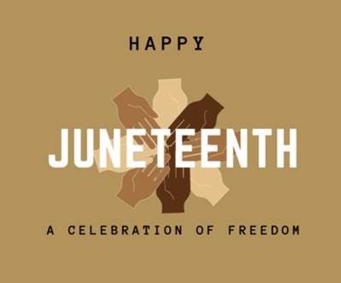

**#StayHome #StaySafe #StayHealthy**

HR