**Issued 6/5/20**

**FANTASTIC FRIDAY**

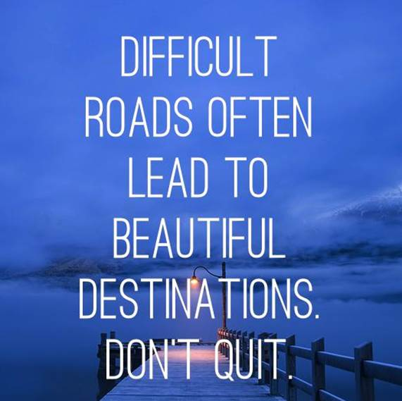

**#StayHome #StaySafe #StayHealthy**

HR