It’s **MOVE it MONDAY**!!!

[Issued 5.11.20]

Here’s a little Move it Monday Funny Motivation. 😊

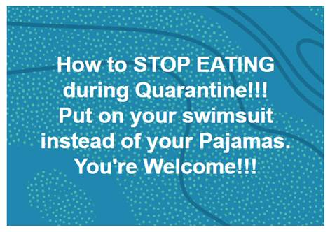

**#StayHome #StaySafe #StayHealthy**

HR