It’s **MOVE it MONDAY**!!!

Issued 6.1.20

Here’s a little Move it Monday Mental Health Motivation.

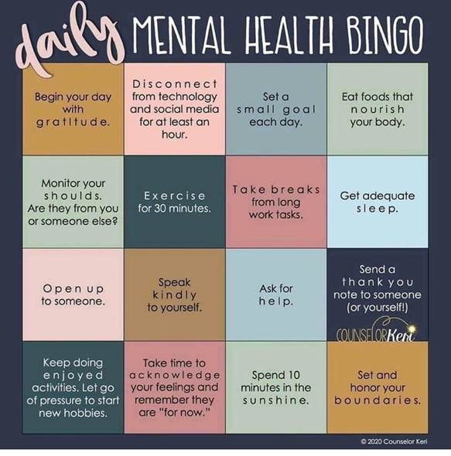

**#StayHome #StaySafe #StayHealthy**

HR