It’s **WATER COOLER WEDNESDAY**!!!

Are you staying hydrated?!?! Here are some more benefits for staying hydrated. Something to think about!

**HYDRATE! HYDRATE! HYDRATE!**

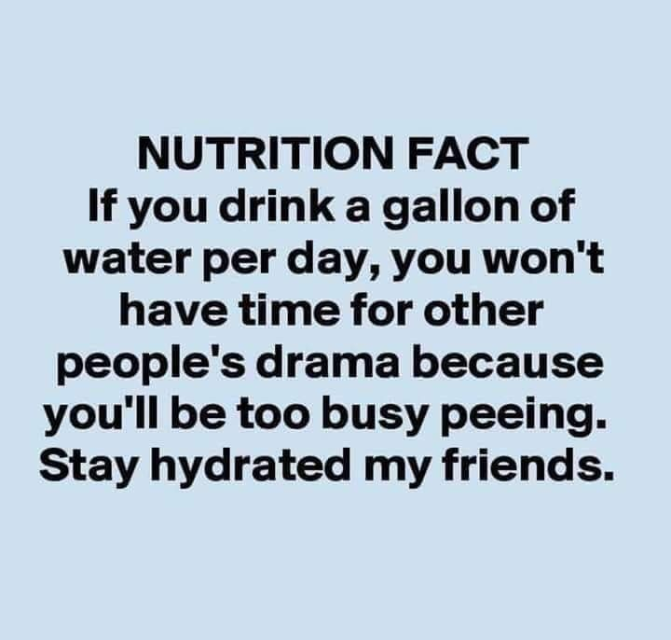

HR