It’s **WATER COOLER WEDNESDAY**!!!

[Issued 4.29.20]

Are you staying hydrated?!?!

Here are some more benefits for staying hydrated especially during exercising.

Something to think about!

**HYDRATE! HYDRATE! HYDRATE!**

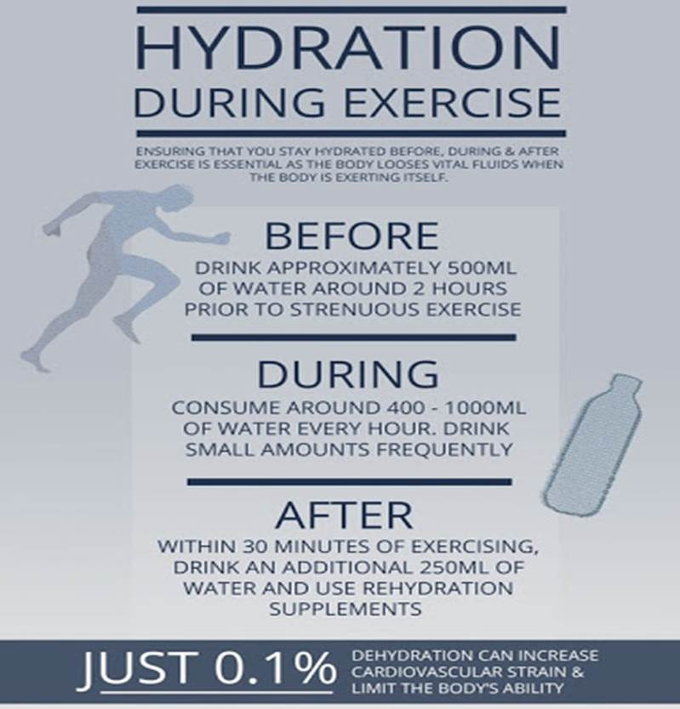

HR