It’s **WATER COOLER WEDNESDAY**!!!

[Issued 5.13.20]

Are you staying hydrated?

Were you aware water helps prevent fatigue?

Something to think about!

**HYDRATE! HYDRATE! HYDRATE!**

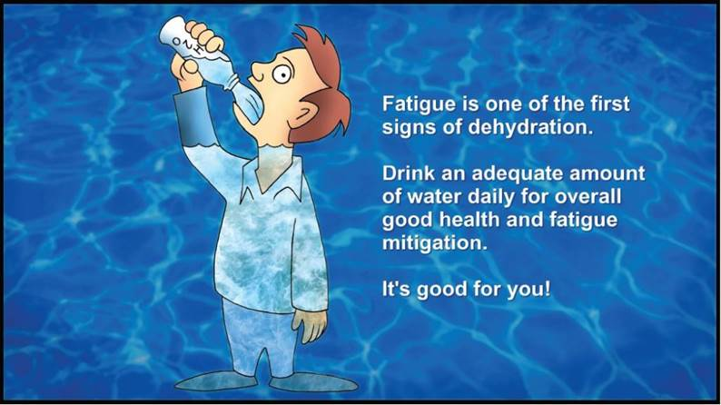

HR