It’s **WATER COOLER WEDNESDAY**!!!

[Issued 5.6.20]

Are you staying hydrated?!?!

Were you aware of how much water your body requires?

Something to think about!

**HYDRATE! HYDRATE! HYDRATE!**

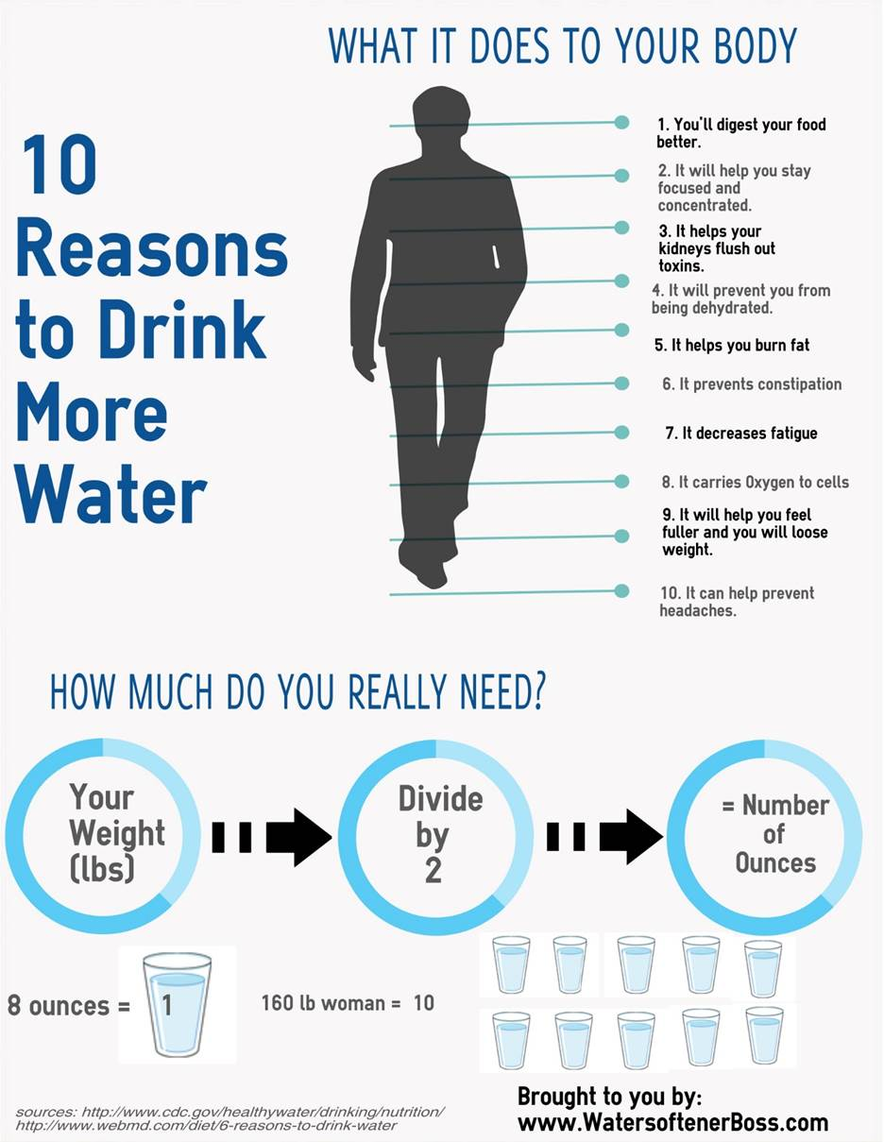

HR