**Membert’s story**

The story of this now-famous Member Processing and Research department mascot began more than two years ago with MDRT’s new office configuration and **Pat McClintock**, who helps the department each year during membership season.

Noticing her colleagues emerge from, then disappear into, their cubicles to ask or answer questions, Pat likened the up-and-down movement -- peeking their heads out from behind their desk areas -- to that of prairie dogs. The next day, Pat brought in Douglas, a stuffed version of the real thing, from one of her trips out West. Douglas hung out with Member Processing for the season and returned home with Pat.

Fast-forward to January 2019, when Pat arrived again for membership season. This time, she brought Douglas’s cousin from another state, who came with a note (below). It appears the poor guy didn’t have a name, so the department held a contest to find a name for Douglas’s cousin.

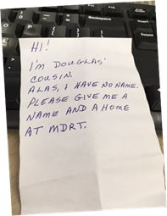

Membert has been with us ever since. He traveled to the Annual Meeting in Miami, where some members from India thought he was a give-away item. Membert posed for a photo, then safely returned home to MDRT. Like our “Elf on a Shelf,” he visits other departments, and has friends in Meeting Services (Gator and Rat) and with Program Production Coordinator **Mike Gutierrez**, who keeps the mascots for meetings.

Membert has different bows for different seasons and holidays. He is very mischievous and does get around. We have had to put out many a “May Day” for Membert, searching the building for him. Membert is just part of the fun at MDRT.

11.27.19