# **AM/GC Virtual Event Team meeting 04/23 – MarCom. Status and Report**

**MEETING LOOK AND FEEL**

* Updated look and feel – PDF
* Banners, identifiers available



[**MEETING WEBSITE**](http://imdrt.org/2020vm/index.html?_ga=2.195987113.460840994.1587493674-546059406.1552932749)

* Translations received and shared with EM.
* Analytics
  + Total traffic 1,203 page views, 547 unique visitors on the day of the announcement (email drove members to the Focus Center first)
  + Seeing between 20-60 visitors a day post-announcement

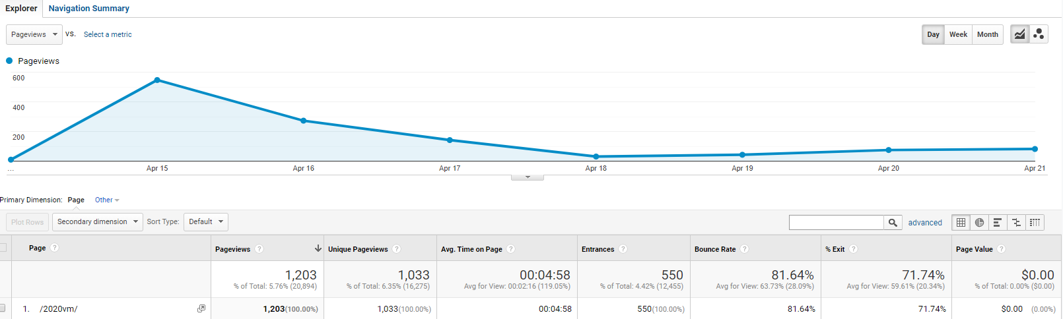

[**EMAIL ANNOUNCEMENT – sent on April 15**](https://mdrt.informz.net/informzdataservice/onlineversion/pub/bWFpbGluZ0luc3RhbmNlSWQ9MjkzNTE5NQ==)

|  |  |  |  |
| --- | --- | --- | --- |
| **Category** | **Number** | **Percent** | **Note** |
| Sent | 29,005 |  | 9 languages |
| Unique Opens | 13,205 | **45.60%** | opened the message |
| Unique Clicks | 2,205 | **16.70%** | clicked the message |

**SOCIAL MEDIA**

* Facebook/Instagram: 4/15, 4/22 and 4/29 (Looking to heavily rely on social media moving forward with email and mail challenges)
* 4/15 post was the 2nd most liked and 2nd most shared item we've posted this year

[**FOCUS CENTER WEBSITE**](https://www.imdrt.org/health/prodkit/?_ga=2.236949124.460840994.1587493674-546059406.1552932749)

* Aggregately, The Focus Center page has more than 32k visits, 23k unique views since launch.
* As the virtual meeting announcement email launched April 15, we gained **8,402** visits from April 15-17
* Most visited languages: English (4.3k); Traditional Chinese (1.6K); Japan – 625. Other in-language pages gained around 200-300 views.
* Top countries: Hong Kong, U.S., Japan, Singapore, Malaysia, Korea, Indonesia, Thailand

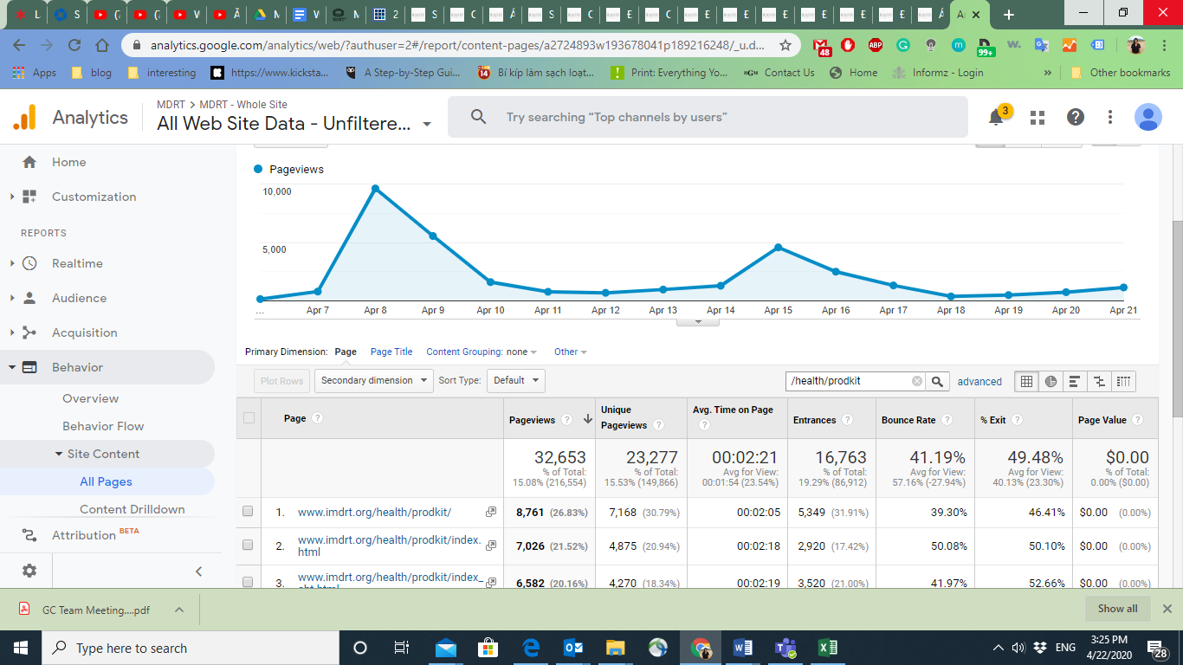

**FAQs.**

* Collecting the questions from Global Markets, (call center?) into a unified document – will compile and use on the website/for talking points

**NEXT STEPS**

* Planning out communications as we receive updates about key dates and information
* Researching other virtual sites and looking at agenda ideas/ thinking about promotion and challenges we may face during this time (many of our address are corporate and people are not at their offices)